***Materials and methods***

*Sample origination*

A longitudinal, cross-sectional non-probability study of 10 certified organic dairy farms in Vermont (US) was carried out in Winter 2019-2020. Participating farms were enrolled… These herds milked an average of 69.5 cows (median: 70; range: 44-105) of various breeds. Five farms housed cows in a tiestall bedded with wood shavings, and 5 utilized a bedded pack system (3 actively managed for composting, 2 static). Three visits were completed at 8 farms, with 1 herd sampled twice and 1 herd sampled 4 times before interruption by the COVID-19 pandemic. On average, 33.6 days elapsed between sequential farm visits for each herd (median: 34; range: 27-43). From each herd, 35 lactating cows of varying parity in early- to mid-lactation were chosen using a stratified random approach to be repeatedly sampled for the duration of the study. Briefly, cows were stratified by lactation number and days in milk and randomly selected across these variables. Cows that were unable to be sampled at a follow-up visit (dried off, left the herd) were replaced with another lactating cow in the herd dictated by convenience. Around the time of the first farm visit, herd records were captured from the record processing center working with each of 9 participating herds (Lancaster DHIA, Manheim, PA; Dairy One Co-Op. Inc., Ithaca, NY) to obtain freshening date and parity for the current lactation. Freshening date and parity for 1 herd was obtained from personal communication with the producer who kept written records. At each farm visit, duplicate quarter milk samples were aseptically collected from each lactating quarter immediately before milking for all enrolled cows according to NMC guidelines (NMC, 2017). [Briefly, after routine pre-milking teat disinfection was completed, researchers, wearing clean disposable gloves, scrubbed teat ends and the distal third of teats with 70% isopropyl alcohol-moistened gauze swabs until teat ends were visibly clean, stripped the quarters, discarding 3-5 squirts of foremilk, and sequentially collected approximately 5-6 mL of milk into each of two sterile 11-mL flip-top vials.] Samples were kept on ice in a cooler during transport until stored temporarily overnight at 4°C in the laboratory, where an aliquot was frozen for SCC measurement, and the remaining milk sample was processed for bacteriological culture.

*SCC measurement*

Aliquots of frozen quartermilk samples were sent to the Vermont State Agricultural and Environmental Laboratory, where samples were thawed at time of processing and quarter-level somatic cell count was determined using flow cytometry (Somacount FC, Bentley Instruments).

*Aerobic culture of milk samples*

Standard aerobic bacteriological culture of quarter milk samples was performed in duplicate within 24 hours of collection to identify the intramammary infection status of each quarter. After being homogenized by gentle inversion, tryptic soy agar plates with 5% sheep blood (Northeast Laboratory, Waterville, ME) were inoculated with 10 μL of milk using disposable plastic inoculating loops. Plates were then incubated in aerobic conditions at 37°C before being read at approximately 48 hrs. A quarter was considered positive for an IMI when greater than or equal to 1 CFU (100 CFU/mL) of a particular isolate was identified with the same morphology for both duplicate samples (interpretation in series; Dohoo et al., 2011). A quarter was considered negative when there was no significant growth on either duplicate plate (i.e., no growth on both plates, growth one plate and no growth from the duplicate sample, or if there was growth on both plates and the morphology of isolates on each plate was different). Interpretation of duplicate quartermilk samples in series results in decreased sensitivity but higher specificity for identifying non-*aureus* staphylococci intramammary infections as compared to a single sample (Dohoo et al., 2011). This approach was chosen to maximize the specificity of culture to identify quarters as positive for a non-*aureus* staphylococci IMI (i.e., minimize false positives), as collection of a large number of samples in the field under time pressure and occasionally with minimally trained personnel resulted in a moderately high rate of contamination (13%). Samples were classified as contaminated if more than 2 different morphologically-distinct isolates grew on a plate. If either one of the two samples or both samples were classified as contaminated, that quarter was removed from analysis.

*Speciation of bacterial isolates*

Isolates cultured from quarters meeting the IMI definition were selected and grown in isolation on blood agar. Standard benchtop tests were done to presumptively identify bacteria following NMC procedure guidelines, including differential growth on selective media, colony morphology, hemolytic pattern, catalase reaction, Gram stain, and coagulase testing (NMC, 2017). Isolates were preserved in tryptic soy broth with a final concentration of 15% glycerol in cryovials and stored at -80°C. Frozen isolates were sent overnight on ice to the University of Missouri for speciation using MALDI-TOF mass spectrometry (Microflex, Bruker Daltonics) with Flex Control software (Bruker Daltonics). The protocol for identifying bacterial isolates with MALDI-TOF mass spectrometry has been described previously (Adkins et al., 2022). Briefly, generated spectra were assigned a score based on similarity with spectra in the manufacturer’s database, as well as the University of Missouri laboratory custom database (Adkins et al., 2018). The confidence levels used for species identification were applied as previously described (Cameron et al., 2017), in which ≥1.7 was used for staphylococcal species-level identification and <1.7 was classified as inconclusive. Suspect staphylococci isolates unable to be identified to the species level and those identified as *Staphylococcus agnetis* or *Staphylococcus hyicus* by MALDI-TOF were speciated using *tuf*gene sequences with a cut-off of 98% identity as previously described (Hwang et al., 2011).

*Selection and description of data set*

The initial data set included 3,331 quarter observations where the bacteriological status of a quarter could be determined. Quarters were then selected that: 1) had a subclinical intramammary infection due to any *Staphylococcus* species (in pure culture) with ≥ 5 associated observations *or* was culture negative; 2) was collected from a cow ≤ 305 days in milk at time of observation; 3) had an associated quarter-level somatic cell count measurement (Figure 1)*.*

*Statistical analysis*

Quarter somatic cell counts, intramammary infection status, cow parity and days in milk data were organized into a spreadsheet (Microsoft Excel, Redmond, WA) and imported into the R Statistical Programming Environment (R Development Core Team, 2023) for analysis. Raw quarter-level somatic cell count was converted to somatic cell score [log2(quarter somatic cell count/1000) + 3] (SCS) in order to address the non-normal distribution of SCC data.

A linear hierarchical repeated measures mixed model was fitted to the data set in order to compare SCS of quarters with Staphylococcus species intramammary infections to culture negative quarters. The “lme” function of the “nlme” package was used to build this model, in which the SCS for each quarter observation was the outcome variable, and *Staph.* species causing IMI (with culture negative quarters as the reference value) was the fixed predictor variable. The number of days in milk at time of sampling was included in the model to adjust the estimates of the *Staph.* species and quarter SCS association for confounding by this variable. The hierarchical structure of the data was addressed by fitting random intercepts for quarter, cow, and herd (observations nested within quarter, quarters nested within cow, and cow within herd). Samples collected at different time points for a given quarter were considered repeated measurements, and a spatial exponential correlation structure was used to account for both the correlation between milk samples collected on the same quarter, and for the variation of this correlation with the varying amount of time between sample collections. The model was:

SCS*ijkl* = β0 + β1 *Staph.* species*ijkl* + β2DIM*ijkl* + β3DIM*ijkl*2 + β4DIM*ijkl*3 + v*l* + u*kl* + w*jkl* + e*ijkl*,

where SCS*ijkl* is the predicted somatic cell score for the *i*th sample of the *j*th quarter of the *k*th cow from the *l*th herd; β0 is the intercept; β1, β2, β3, and β4 are the regression coefficients for *Staph.* species, and DIM as a cubic term (to correct for the nonlinear relationship between DIM and SCS); and *vl*, *ukl*, *wjkl*, and *eijkl*are the herd random effect, cow random effect, quarter repeated effect, and sample error term, respectively (approximate normal distribution assumed). Biologically plausible interactions were investigated between IMI status, SCS, and parity variables. Statistical significance was determined using an F-test for interaction terms and a t-test for fixed effects, with significance declared at P ≤ 0.05. Final model fit was assessed by checking the homoscedasticity and normality of residuals (graphing of residuals vs. predicted values and Q-Q plots, respectively).

***Results***

The initial data set included 3,331 quarter-level observations, with 22 different species of staphylococci and mammaliicocci identified. Staphylococcus and mammaliicoccus species causing IMI with < 5 quarter observations excluded from the data set included: *M. fleurettii, M. sciuri, M. vitulinus, S. auricularis, S. capitis, S. cohnii, S. epidermidis, S. gallinarum, S. hominis, S. pseudintermedius, S. saprophyticus,* and *S. succinus*. The final data set consisted of 2,260 observations: 648 quarters with an intramammary infection due to 10 different *Staph.* sp. (each with at least 5 associated observations), and 1,972 culture negative quarters. Observations included in the final data set came from 1,272 quarters of 360 cows across all 10 herds included in the field study. The mean (median; range) number of cows included per herd was 36 (36; 34-39), whereas the number of quarters sampled per cow was 3.5 (2; 1-4). The mean number of observations per quarter included was 2.1 (2; 1-4). Twenty-seven percent of observations were the sole observation contributed to the data set by a given quarter, 41% came from quarters contributing 2 time points, and 31% and 1% came from quarters contributing 3 and 4 observations, respectively. The average time elapsed between sequential observations of a quarter was 37.1 days (median: 34.5; SD: 11.6), with an overall range of 27-96 days.

*Staph. chromogenes* was the most commonly-found species (59% of IMI quarter observations), followed by *Staph. aureus* (17%)*, Staph. haemolyticus* (6%)*,* and *Staph. simulans* (5%)*.* A large amount of variability was observed in the somatic cell score for culture negative quarters and those infected with a number of different *Staph.* species, especially *S. chromogenes* and *S. aureus* (observed quarter SCS data presented in Figure 2). The observed SCS for *S. chromogenes* IMI ranged from -2.64 to 8.93 (median: 3.26, and equivalent to 2,000 to 6.1 million cells per ml), with 29.7% of observations of having an SCS ≤ 4. The observed SCS for *S. aureus* IMI ranged from -0.64 to 10.49 (median: 5.93, and equivalent to 8,000 to 18 million cells per ml), with 87.5% of observations of having an SCS > 4.

The final model comparing somatic cell scores of quarters infected with *Staphylococcus* species to culture negative quarters adjusted for days in milk is presented in Table 1. Somatic cell score was significantly higher in quarters infected with *S. agnetis, S. aureus, S. chromogenes, S. devriesei, S. haemolyticus, S, hyicus, S. simulans, S. warneri, and S. xylosus* compared to uninfected quarters (P ≤ 0.05; Table 1). The interaction between IMI status and DIM was not significant (P = 0.42). [The effect of parity on SCS was visualized using the raw data, and SCS appeared to have a positive linear relationship with parity. When SCS was plotted as function of IMI status by parity using the raw data, most bacterial species (with the exception of *S. hyicus,* n = 6 observations) had a relatively constant effect on SCS regardless of parity.] A model with an interaction term between IMI status and parity found that the interaction between IMI status and parity was not significant (P = 0.86), but parity and bacterial species separately were both significant predictors of SCS (P < 0.0001). A model was attempted with a three-way interaction term between DIM (3-degree polynomial term), IMI status, and parity, but would not converge due to complete data separation. An additive model with DIM (3-degree polynomial term), IMI status, and parity found all three variables to be statistically significant (P < 0.0001) predictors of SCS. When compared to the model with only DIM and IMI status, the model including parity changed the coefficients for each *Staph.* sp. group by ≤ 5%, and standard errors by ≤ 1%. As the effect of parity was the same across all groups of IMI status, and the impact of its inclusion was minimal on the coefficients of the variable of interest, only results from the model including DIM (3-degree polynomial term) and IMI status on quarter SCS are presented in the interest of simplicity.

Least square means estimates of quarter somatic cell scores across DIM for the ten different *Staph*. species modeled as compared to culture negative quarters are presented in Figure 3. Estimates for each species are presented for the observed range of days in milk available from included quarter milk samples. Infection by most *Staph.* species elevated quarter SCS notably above the SCS for no growth quarters (Figure 3).

Predicted raw somatic cell counts for quarters infected with different *Staph.* species at 91 days in milk are presented in Table 2. The highest cell count was for quarters infected with *S. warneri,* followed by *S. aureus, S. agnetis,* and *S. hyicus* (Table 2)*.* Intramammary infection with the most commonly-found species, *S. chromogenes,* resulted in a quarter somatic cell score of 80,376 cells/mL for a cow 91 days in milk (Table 2).

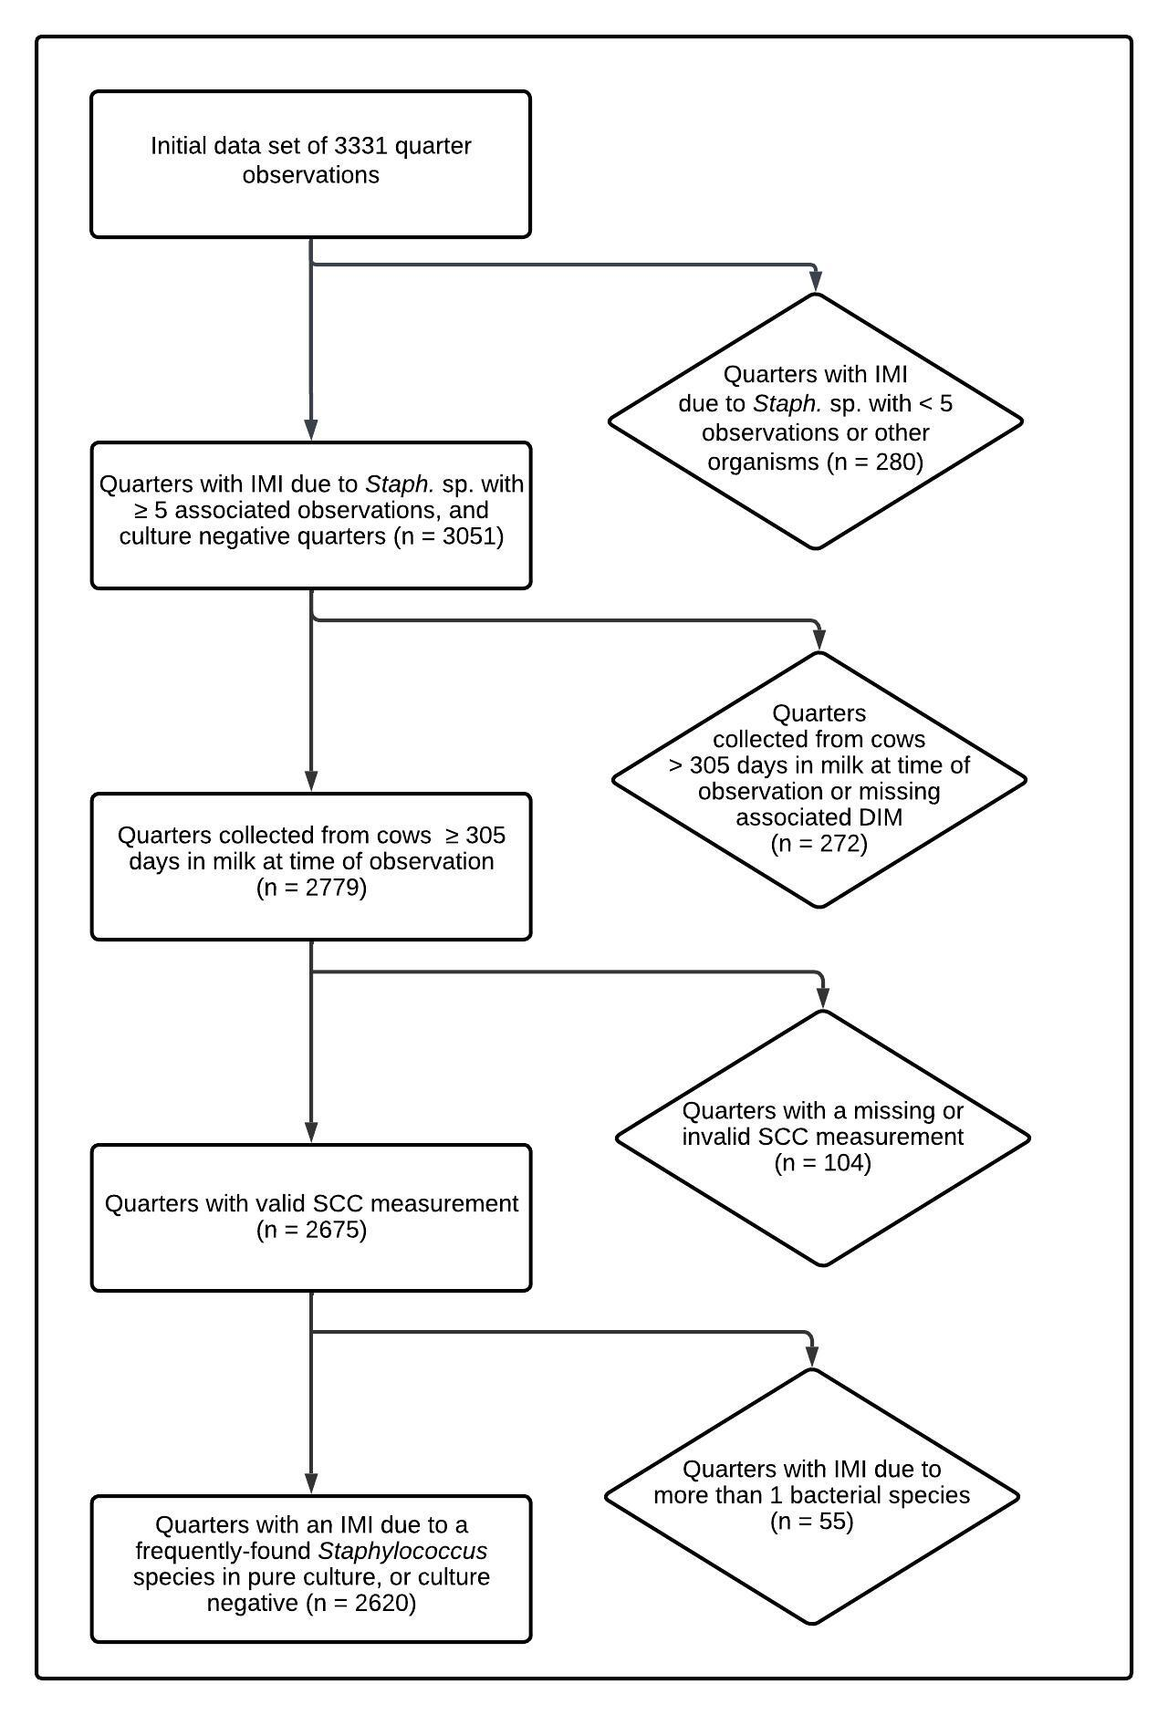

Figure 1.Flow diagram describing selection of final data set.

|  |  |  |  |
| --- | --- | --- | --- |
| Table 1. Final multivariable model describing the effect of intramammary infection with frequently-isolated *Staphylococcus* species on quarter somatic cell score, adjusted for days in milk at time of sampling. | | | |
| *Fixed effects* | | | |
| *Staphylococcus* sp. | No. quarter observations | Coefficient estimate (SE) | *P*-value |
| Intercept | - | -0.03 (0.29) | 0.90 |
| No growth | 1972 | *Reference* | *Reference* |
| *S. agnetis\** | 21 | 3.76 (0.45) | <0.00001 |
| *S. aureus\** | 112 | 4.81 (0.22) | <0.00001 |
| *S. chromogenes\** | 384 | 2.88 (0.12) | <0.00001 |
| *S. devriesei\** | 15 | 1.62 (0.54) | 0.003 |
| *S. equorum* | 9 | 0.12 (0.48) | 0.81 |
| *S. haemolyticus\** | 40 | 1.77 (0.31) | <0.00001 |
| *S. hyicus\** | 6 | 3.23 (0.85) | 0.0001 |
| *S. simulans\** | 35 | 3.11 (0.39) | <0.00001 |
| *S. warneri\** | 15 | 5.18 (0.60) | <0.00001 |
| *S. xylosus\** | 11 | 2.96 (0.62) | <0.00001 |
| Days in milk | - | -0.003 (0.01) | 0.54 |
| Days in milk2 | - | 0.00001 (0.00004) | 0.73 |
| Days in milk3 | - | <0.00001 (<0.00001) | 0.53 |
| *Random effects* | Variance |  | |
| Farm | 0.28 |  | |
| Cow | 1.0 |  | |
| Quarter | 0.47 |  | |
| * Quarter somatic cell score differs from negative controls (P ≤ 0.05) | | | |

|  |  |  |
| --- | --- | --- |
| Table 2. Estimated quarter somatic cell count by intramammary infection status at 91 days in milk (13 weeks) for frequently-isolated *Staphylococcus* species and culture negative quarters. [which one we like better?] | | |
| *Staphylococcus* sp. | Estimated quarter somatic cell count (cells/mL) | 95% lower and upper confidence level (cells/mL) |
| No growth | 10,927 | 8,056 - 14,822 |
| *S. agnetis* | 148,437 | 69,021 - 319,232 |
| *S. aureus* | 307,101 | 197,323 - 477,951 |
| *S. chromogenes* | 80,376 | 56,942 - 113,454 |
| *S. devriesei* | 33,513 | 13,597 - 82,599 |
| *S. equorum* | 11,855 | 5,292 - 26,556 |
| *S. haemolyticus* | 37,333 | 21,217 - 65,688 |
| *S. hyicus* | 102,478 | 26,368 - 398,281 |
| *S. simulans* | 94,617 | 48,346 - 185,175 |
| *S. warneri* | 395,190 | 148,189 - 1,053,891 |
| *S. xylosus* | 84,985 | 30,798 - 234,512 |

|  |  |  |  |
| --- | --- | --- | --- |
| Table 2. Estimated raw quarter somatic cell count by intramammary infection status at 91 days in milk (13 weeks) for frequently-isolated *Staphylococcus* species and culture-negative quarters. [which one we like better?] | | | |
| *Staphylococcus* sp. | Estimated quarter somatic cell count (× 1,000 cells/mL) | 95% lower confidence level (× 1,000 cells/mL) | 95% upper confidence level (× 1,000 cells/mL) |
| No growth | 10.9 | 8.1 | 14.8 |
| *S. agnetis* | 148.4 | 69 | 319.2 |
| *S. aureus* | 307.1 | 197.3 | 478 |
| *S. chromogenes* | 80.4 | 56.9 | 113.5 |
| *S. devriesei* | 33.5 | 13.6 | 82.6 |
| *S. equorum* | 11.9 | 5.3 | 26.6 |
| *S. haemolyticus* | 37.3 | 21.2 | 65.7 |
| *S. hyicus* | 102.5 | 26.4 | 398.3 |
| *S. simulans* | 94.6 | 48.3 | 185.2 |
| *S. warneri* | 395.2 | 148.2 | 1,053.9 |
| *S. xylosus* | 85 | 30.8 | 234.5 |

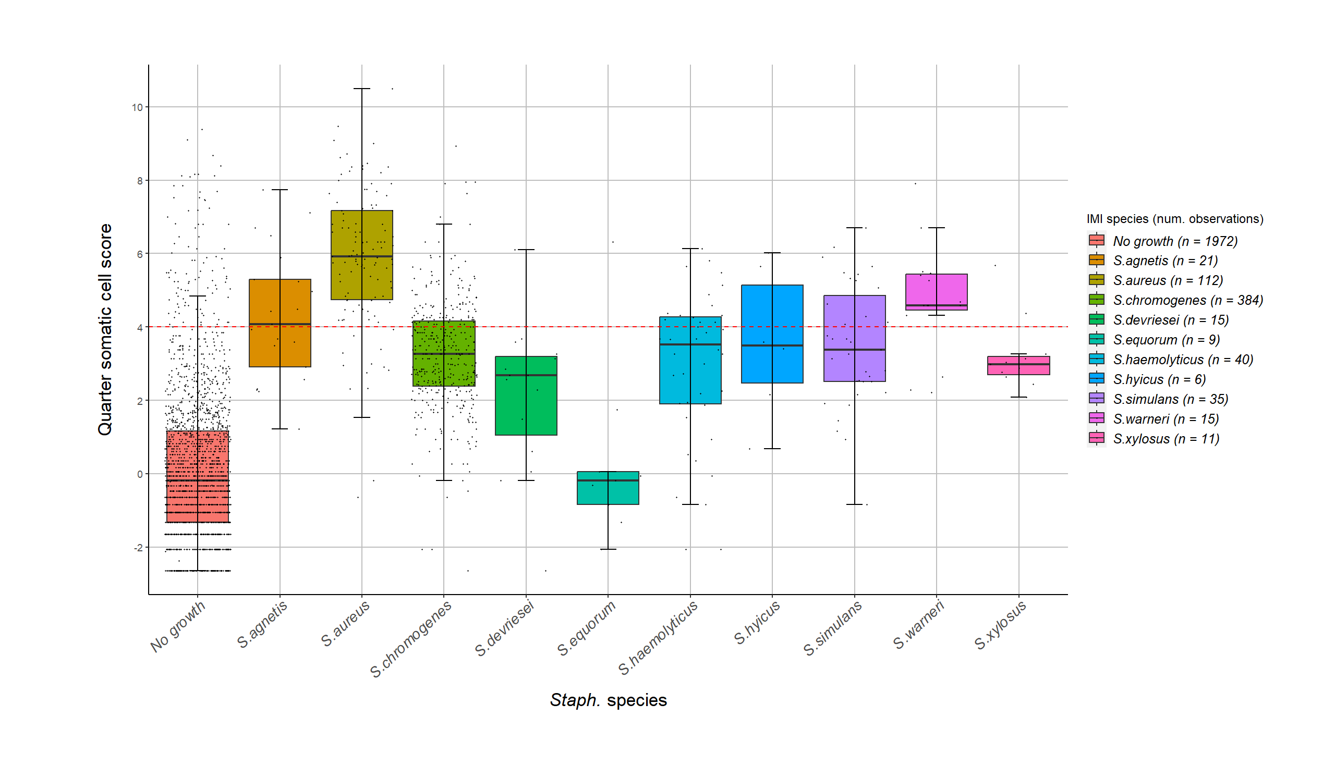

Figure 2. Somatic cell score for quarters with an intramammary infection due to *Staphylococcus* species and culture negative control quarters. The red dotted line is at a somatic cell score of 4. The observed data are displayed (i.e., quarters that were repeatedly positive for the same species contributed with several SCC measurements). Each box contains 50% of the data for a species, the median (line), and is bounded by the 25th and 75th percentiles. The upper whisker represents the largest observation less than or equal to the 75th quartile plus 1.5 times the interquartile range, while the lower whisker represents the smallest observation greater than or equal to the 25th quartile minus 1.5 times the interquartile range.

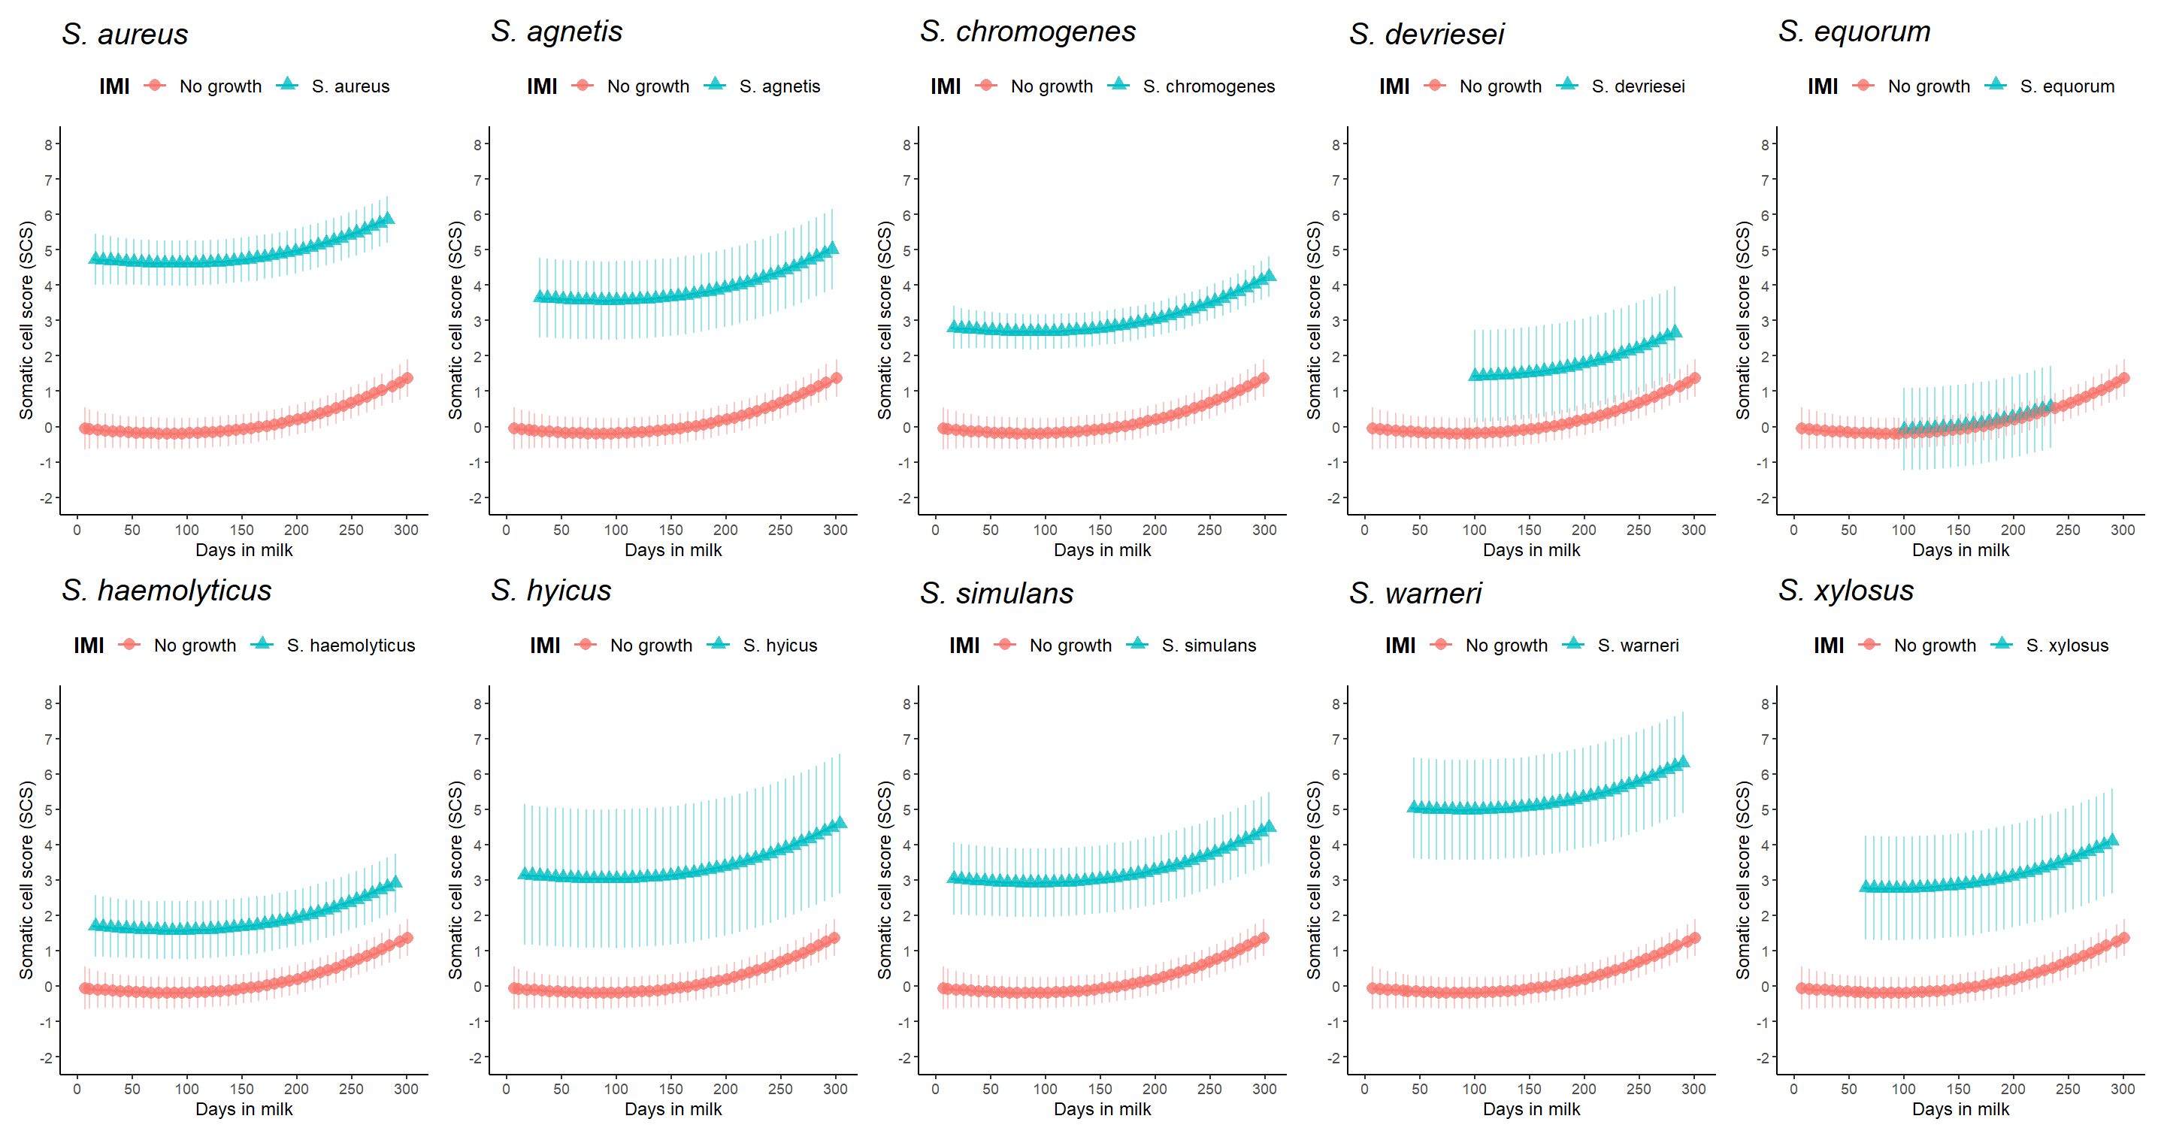

Figure 3. Quarter somatic cell score least square means estimates as a function of *Staph.* species IMI and days in milk, compared to culture negative quarters. Model estimates for each species are only presented for the range of days in milk for IMI observations in the data set. Error bars represent the 95% confidence interval.

Adkins, P. R. F., S. Dufour, J. N. Spain, M. J. Calcutt, T. J. Reilly, G. C. Stewart, and J. R. Middleton. 2018. Molecular characterization of non-aureus Staphylococcus spp. from heifer intramammary infections and body sites. J. Dairy Sci. 101(6):5388-5403.

Adkins, P. R. F., L. M. Placheta, M. R. Borchers, J. M. Bewley, and J. R. Middleton. 2022. Distribution of staphylococcal and mammaliicoccal species from compost-bedded pack or sand-bedded freestall dairy farms. J Dairy Sci 105(7):6261-6270.

Cameron, M., H. W. Barkema, J. De Buck, S. De Vliegher, M. Chaffer, J. Lewis, and G. P. Keefe. 2017. Identification of bovine-associated coagulase-negative staphylococci by matrix-assisted laser desorption/ionization time-of-flight mass spectrometry using a direct transfer protocol. J. Dairy Sci. 100(3):2137-2147.

Dohoo, I., S. Andersen, R. Dingwell, K. Hand, D. Kelton, K. Leslie, Y. Schukken, and S. Godden. 2011. Diagnosing intramammary infections: Comparison of multiple versus single quarter milk samples for the identification of intramammary infections in lactating dairy cows. J. Dairy Sci. 94(11):5515-5522.

Hwang, S. M., M. S. Kim, K. U. Park, J. Song, and E. C. Kim. 2011. Tuf gene sequence analysis has greater discriminatory power than 16S rRNA sequence analysis in identification of clinical isolates of coagulase-negative staphylococci. J Clin Microbiol 49(12):4142-4149.

National Mastitis Council. 2017. Laboratory Handbook on Bovine Mastitis. Third ed. National Mastitis Council, Inc., New Prague, MI.

R Development Core Team. 2023. R: A Language and Environment for Statistical Computing. R Foundation for Statistical Computing, Vienna, Austria.